S&P 500 Company Clustering Analysis
  - Unsupervised Learning Project Report
Alex Nite

Introduction
The purpose of this project was to explore whether companies in the S&P 500 naturally group together based on their financial and operational characteristics through Unsupervised Learning techniques. I chose unsupervised learning here instead of supervised, because there was no pre-defined label or target variable for company types, and I wanted the data to reveal its own structure rather than predicting a known outcome. K Means and Agglomerative Hierarchical Clustering methods were applied twice, once on the original standardized features and again after using Principal Component Analysis to reduce dimensionality. This allowed me to study not only the cluster structures themselves but also how PCA changes the way those structures appear.
The S&P 500 dataset contains a couple of company attributes that reflect size, profitability, pricing, staffing as well as growth patterns. The variables I specifically focused on were:
- Marketcap (log-transformed): A measure of company size and overall valuation.
- Ebitda (signed log): A profitability indicator that also distinguishes between positive and negative earnings.
- Currentprice (log-transformed): A representation of stock price magnitude without the distortions of raw scale.
- Fulltimeemployees (log-transformed): A proxy for operational scale with respect to number of employees.
- Revenuegrowth: A direct measure of how quickly a company is expanding.
Together, I believe these features do a good job of capturing the broad economic profiles of each firm; for example, some companies are large but have low growth while others have high revenue growth but smaller workforces. By using clustering methods, I wanted to see whether consistent patterns emerged across these dimensions.
The Project began with a thorough Exploratory Data Analysis (EDA), I then cleaned and transformed the dataset so that clustering would be meaningful and fair. As I moved into modeling, I paid close attention to how different variables shaped the clusters, how the optimal number of clusters changed with PCA, and what the cluster profiles revealed about the companies themselves.

Exploratory Data Analysis
A close inspection of the dataset reveals that the S&P 500 companies dataset contained financial variables such as Market Cap, EBITDA, Current Price, Revenue Growth, and Full Time Employees. It also had categorical Values like State, Country, Symbol, Exchange, Industry, Sector and City as well as a column that summarized the company.
These financial variables have very different scales and when graphed tend to be right skewed. This matters because clustering algorithms rely heavily on distances between points, and skewed data can distort those distances.
Financial Variables Distribution Analysis
- Distributions of Original Numeric Variables
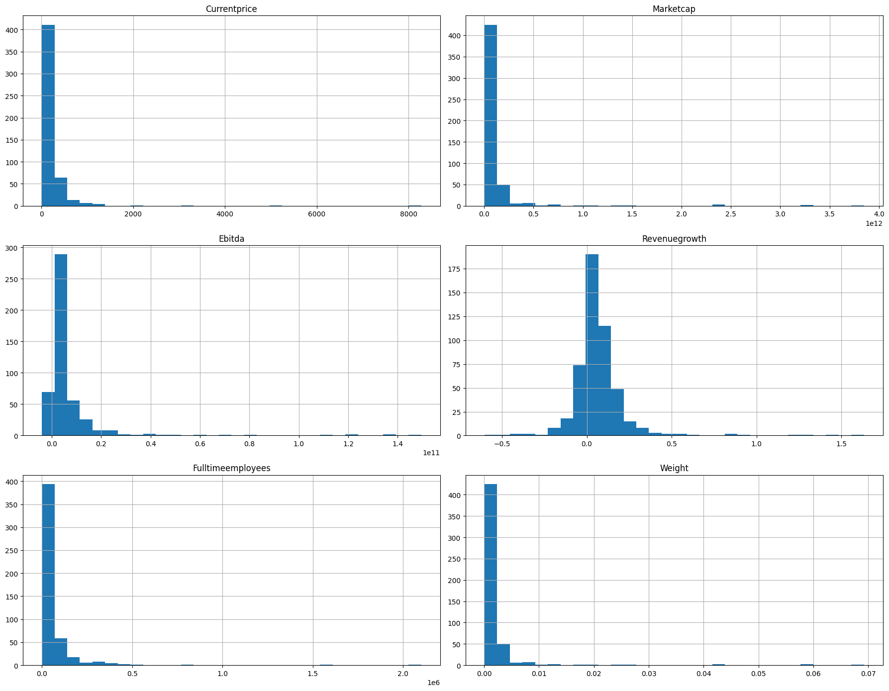
The EDA began by examining the frequency distributions of the original numeric variables which were Current Price, Market Cap, EBITDA, Full-Time Employees, Weight, and Revenue Growth. These histograms do a good job of revealing some important insights about the data's underlying structure which informed the next EDA steps.
Revenue Growth appears more centrally distributed, showing a relatively balanced spread around its median.
However, variables such as Current Price, Market Cap, EBITDA, Full-Time Employees, and Weight, the distributions were strongly right skewed. I believe this indicates that that while most companies have relatively low values for these metrics, there are a small number of companies that have extremely high values, resulting in the long tails to the right.
This pronounced skewness indicates that the raw data is far from normally distributed. Because many of the clustering algorithms rely heavily on distance calculations, and such extreme values can disproportionately influence cluster formation, the next is to revisualize the skewed variables under log transformation for more balanced Distributions.
- Log-Transformed Numeric Variables
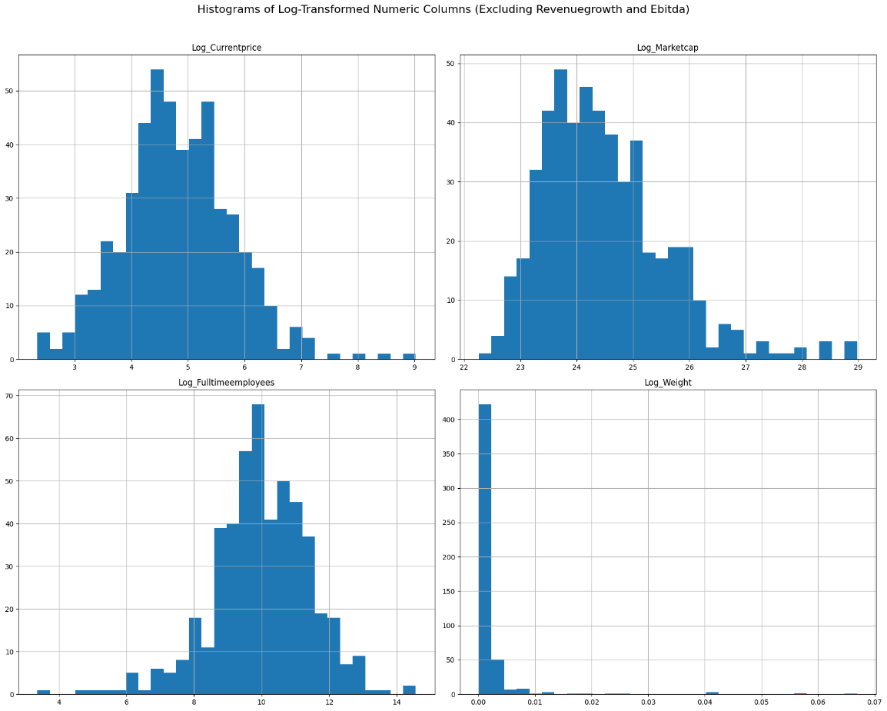
To address the skewness observed in the original data, I applied log-base transformations to Current Price, Market Cap, Full-Time Employees, and Weight.
The transformations were successful in a way because the histograms now show a comparatively reduced skew for most variables. Log-transformed Full-Time Employees still showed a minor left skew, while Log Market Cap and Log Current Price displayed some residual right skew. Log weight is still right skewed but mostly centered around 0.
- EBITDA Signed Log
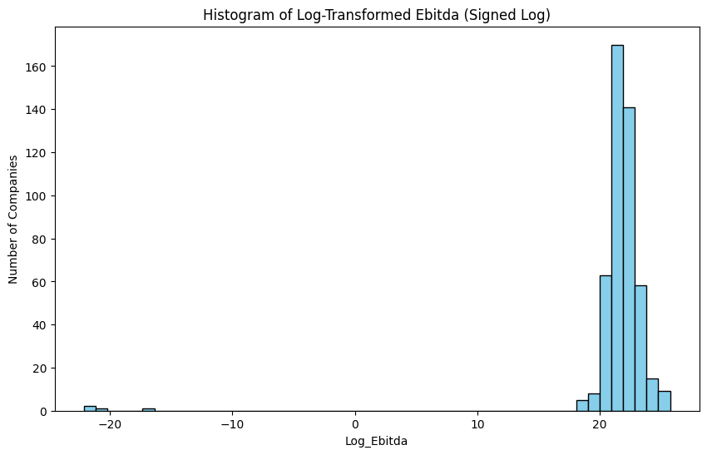
EBITDA’s log transformation was done separately and differently than the other variables because of the presence of negative values. Instead of the normal Log transformation, it had a signed log transformation done that allowed proper handling of both positive and negative values.
As we can see, even after the sign log transformation, EBITDA still has some outliers that are making it left skewed.
Transformation Conclusion
While a lot of variables still retain some of their skewness, the transformations were able to substantially reduce the influence of extreme values allowing for a more stable foundation for clustering. Revenue Growth was left untransformed because it already followed a roughly normal distribution, which is sufficient for clustering.

- Outlier Detection via Boxplots
Continuing the EDA, a Boxplot was also generated for each numeric variable to identify the presence of outliers in the data set. The resulting visualization confirmed a number of outliers, especially for Market Cap and EBITDA, where several points were far above the upper whiskers.
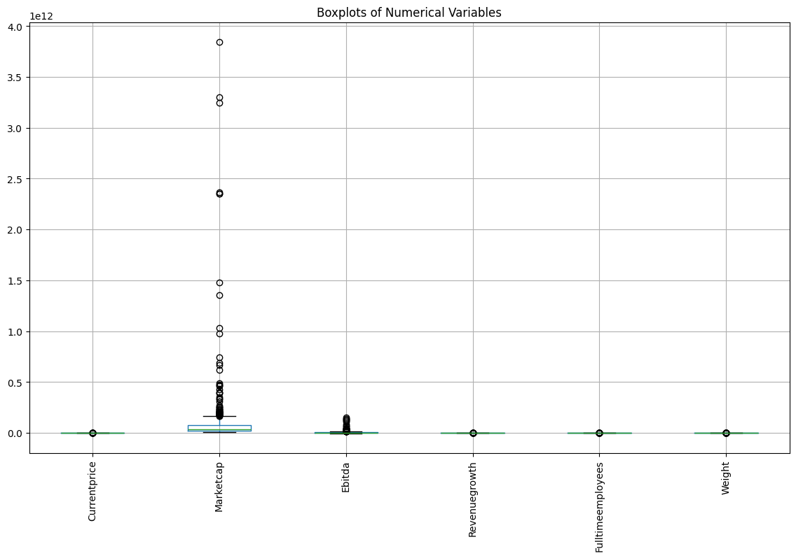
The Box Plot also makes the scale differences between variables apparent. For example, Market Cap spans several orders of magnitude compared to Revenue Growth, which is tightly clustered. These differences highlight the importance of standardizing the data before any clustering process occurs to ensure that variables with larger scales do not dominate the clustering or the PCA process.
While doing the Box Plot for EDA, I also generated a box plot that used the log transformed versions, the results were similar to the non-log transformed versions. As a result, the first non-log transformed version of Box Plot was kept.
- Correlation Analysis
A correlation heat map matrix was produced to study the strength of relationships between different numerical variables.
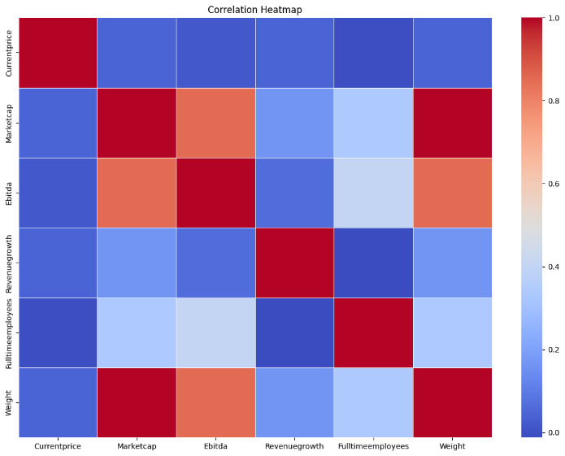
Correlation Matrix Findings:
- Strong Positive Correlation: Market Cap and Weight were highly positively correlated, indicating that these variables often move together and may provide overlapping information.
- Moderate Correlations: Market Cap and EBITDA, as well as EBITDA and Weight, showed moderate positive correlations.
- Weak Correlations: Revenue Growth and Full-Time Employees showed very low correlations with almost every other variable. This could suggest that they provide independent information that could be valuable for clustering.
Since Market Cap and Weight have a high correlation according to matrix, using both variables at once could lead to multicollinearity issues. As such, removing one of the highly correlated variables would simplify the model without the risk of any significant loss of information. As result, moving forward for Clustering and PCA, I dropped Weight while retaining Market Cap to reduce redundancy.

Data Cleaning and Preparation
- Data Cleaning
Some variables had missing values, especially EBITDA, Revenue Growth, and Employee Count. Since these variables are central to company structure and financial health, I imputed them using median values instead of dropping them altogether. Median also tends to work better than mean imputations because means can be easily skewed by extreme high or low values leading to skewed distributions.
State as a categorical variable had too many missing entries and as a result was dropped because it did not contribute significantly to this analysis. While Country and City did not have any missing values, as categorical values that were not used, they were also dropped.
- Data Preparation
Transformation
- Market Cap, Current Price, Full Time Employees were Log Transformed.
- EBITDA underwent Sign Log Transformation
Feature Selection
For clustering, these are five variables in the final dataset:
- Log Market Cap
- Signed Log EBITDA
- Log Current Price
- Log Full Time Employees
- Revenue Growth
Standardization
As we noted in box plots, EBITDA and Market Cap span several magnitudes while the other variables don’t. Since clustering depends on distances, I standardized all the features. This standardization will ensure that no single variable dominates the clustering simply because of its scale.
Selecting K for K Means Clustering
Elbow Methods were used to select the K for K means Clustering before and after PCA
Selecting K for Agglomerative Hierarchical Clustering
Visual Dendograms were generated pre and post PCA to select the correct K for Agglomerative Hierarchical Clustering.

Principal Component Analysis
PCA is a dimensionality reduction technique that reduces the number of features in a dataset by combining them into a few uncorrelated components while still retaining most of the original information. In order to better understand the structure of my data and prepare it for clustering, PCA was applied.
Variance
I ran the PCA three times with different percentages, 80%, 90% and 95% to understand how the number of components affects the amount of variance that is captured in the data set. The results showed that four components explained roughly 80–90% of the total variance, while five components captured about 95% of the variance.
I decided to choose 90% because it allowed me to scale back to 4 components instead of 5 without missing any important information. This reduction will help simplify the clustering process and make it easier to visualize and interpret the patterns in the data moving forward.
PCA Loadings
Component | PC1 | PC2 | PC3 | PC4
Log_Marketcap | 0.644 | -0.091 | -0.098 | -0.098
Signed_Log_Ebitda | 0.357 | 0.146 | 0.716 | 0.569
Log_Currentprice | 0.416 | 0.209 | -0.670 | 0.452
Log_Fulltimeemployees | 0.480 | -0.550 | 0.121 | -0.425
Revenuegrowth | 0.233 | 0.790 | 0.118 | -0.532
The PCA loadings described above reveal how much each original feature contributes to each principal component. As such, understanding these loadings is essential for interpreting the new components in terms of the original variables.
PC1
PC1 was dominated by Market Cap, meaning that it captured the variance as a result of Market Cap better than any other feature. As a result, PC1 here, represents the size/ scale of a company as measured by its market capitalization.
PC2
It has positive loadings for Revenue Growth and negative loadings for Full-Time Employees. This would indicate that PC2 represents some sort of growth or productivity dimension.
PC3
This had positive loadings for EBITDA and negative loadings for Current Price. As a result, PC3 might highlight a factor that is related to profitability with respect to share price.
PC4
Here we see combined positive loadings for EBITDA and Current Price with negative loadings for Full-Time Employees and Revenue Growth. Based on that, I believe PC4 might be capturing a more complex relationship among the size, profitability, and growth metrics.
Moving forward, using this PCA-transformed data for clustering will let the algorithms focus on the main patterns in the data instead of getting distracted by noise or features that overlap too much. This way, whatever clusters are created, will be more meaningful and stable, capturing the real business characteristics like company size, growth efficiency etc.

K-Means Clustering
K-Means is an unsupervised learning algorithm that groups data points into clusters based on their similarity. It works by iteratively assigning points to clusters in a way that minimizes the distance between each point and its cluster centroid (this is the average of the points in that cluster). The distance it minimizes is Euclidean distance, meaning the straight-line distance between points in the feature space.
The aim of using K Means as method of clustering was to group the S&P 500 companies into distinct clusters based on their shared numerical characteristics.
The K Means clustering Algorithm was repeated twice, once on the original data set and then again after PCA.
Pre PCA
K-Means was applied directly to the clean and standardized dataset, which contained the transformed and scaled features: Log_Marketcap, Signed_Log_Ebitda, Log_Currentprice, Log_Fulltimeemployees, and Revenue Growth.
To determine the optimal number of clusters, I used the elbow method, which plots the Within-Cluster Sum of Squares (WCSS) against different k values. The WCSS essentially measures how tightly data points cluster around their centroid, and the “elbow” point indicates where adding more clusters stops providing meaningful reductions in WCSS.
Based on this graph, I noted the elbow to be around k=4.
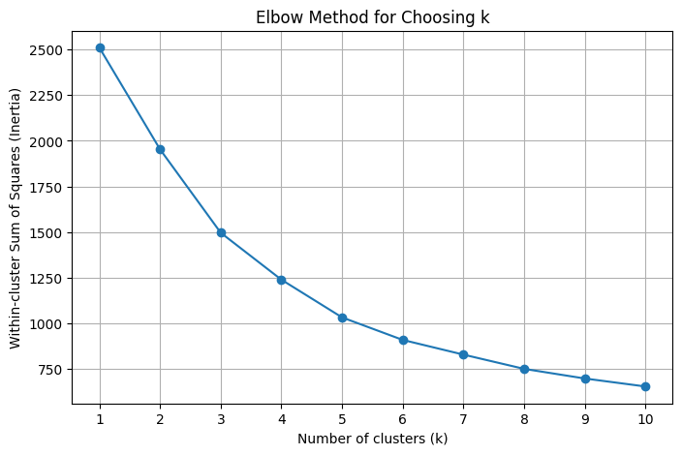
K means with K=4 was then run. Here’s what the resulting cluster sizes looked like:
Cluster Sizes:
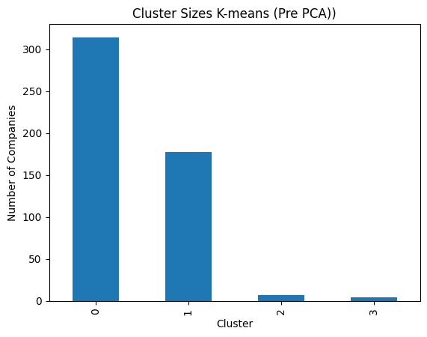
The cluster sizes are highly imbalanced. There are also two very small clusters that most likely captured outliers or specialized companies.
Hierarchical cluster centroids:
Cluster | Log_Marketcap | Signed_Log_Ebitda | Log_Currentprice | Log_Fulltimeemployees | Revenuegrowth
0 | -0.499 | -10.707 | -0.406 | -0.063 | -1.446
1 | -0.649 | -0.031 | -0.537 | -0.320 | -0.304
2 | 0.956 | 0.332 | 0.290 | 0.917 | -0.006
3 | 0.096 | -0.022 | 0.906 | -0.693 | 0.843

- Cluster 0: 314 companies Average Performers
  - Have extremely low market cap, EBITDA, and revenue growth.
- Cluster 1: 177 companies Solid Mid-Sized Growth
  - This seems to represent smaller companies with modest growth and near-average profitability
- Cluster 2: 7 companies High-Value, High-Employee Giants
  - It captures the large, established leaders. We see high market cap, many employees, strong EBITDA, but growth near the mean
- Cluster 3: 4 companies High-Growth Niche
  - This represents the high-growth, high-valuation segment, fewer employees, but rapid revenue expansion and strong stock prices

Post PCA
PCA was conducted to reduce the five-dimensional dataset to four principal components that captured about 90% of the variance. K-Means Clustering Algorithm was run again based on the PCA.
Before beginning the K Means, the elbow method was also re run to see if the number of clusters changed because of the PCA. This time, the elbow appeared more pronounced at k=3, but I still ran k=4 for comparison to see how the clustering structure changed.
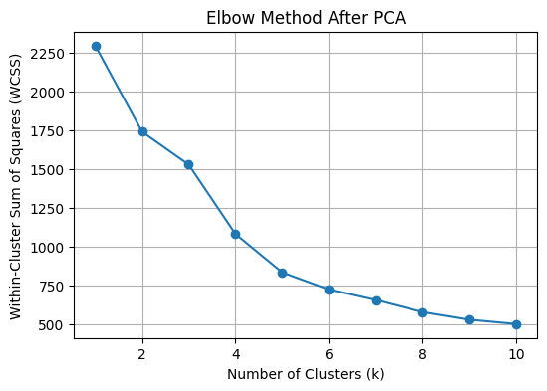

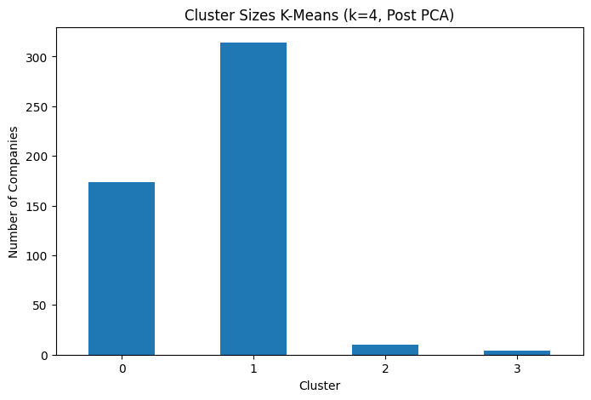
Cluster Centroids K=4
 | PC1 | PC2 | PC3 | PC4
0 | 1.356 | -0.246 | -0.226 | 0.014
1 | -0.743 | 0.043 | 0.195 | 0.149
2 | 1.390 | 4.039 | 0.879 | -2.743
3 | -4.684 | -2.710 | -7.526 | -5.425

Cluster sizes are still somewhat imbalanced.
- Cluster 0 174 members : Established Players
  - Captures large, stable companies.
- Cluster 1 314 members : Diverse
  - Covers smaller and mid-sized firms with mixed profiles.
- Cluster 2 10 members : High Cap
  - Isolates very large, mega-cap companies defined primarily by their extreme size and market capitalization; while some may have growth, their main distinguishing feature is scale and often mature profitability, not just exceptional growth
- Cluster 3 4 members : High Growth Niche
  - This contains the ultra-niche outliers with extreme growth and valuation

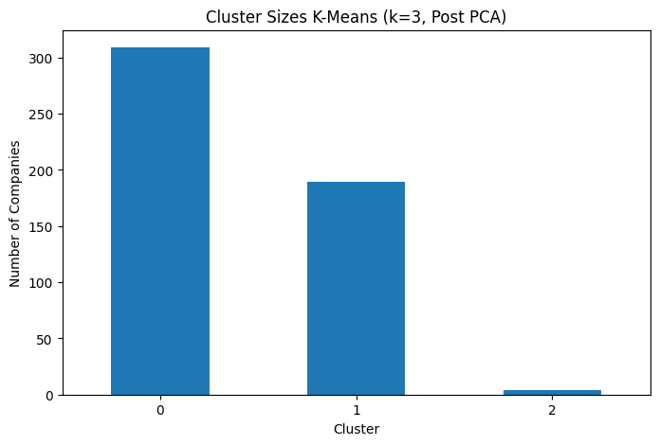
Cluster Centroids K=3
 | PC1 | PC2 | PC3 | PC4
0 | -0.756 | 0.013 | 0.207 | 0.152
1 | 1.335 | 0.036 | -0.179 | -0.134
2 | -4.684 | -2.710 | -7.526 | -5.425

Cluster sizes here could be considered slightly more balanced
- Cluster 0 309 members : Average Performers
  - Groups smaller, average-performing firms together
- Cluster 1 189 members : Established Players
  - Contains large, stable companies
- Cluster 2 4 members : High Growth Niche
  - Remains the group with ultra-niche, high-growth outliers.

Comparing Pre vs Post PCA K Means
Clustering Method | Cluster Label | Number of Members (Size) | Within-Cluster Sum of Squares (WCSS)
Pre-PCA , K=4 | Cluster 1 | 4 | 13.59
K Means | Cluster 2 | 244 | 451.72
 | Cluster 3 | 158 | 331.23
 | Cluster 4 | 96 | 490.05
Post-PCA, K=4 | Cluster 0 | 174 | 370.93
K-Means | Cluster 1 | 314 | 595.81
 | Cluster 2 | 10 | 58.23
 | Cluster 3 | 4 | 13.48
Post-PCA, K=3 | Cluster 0 | 309 | 575.74
K-Means | Cluster 1 | 189 | 704.66
 | Cluster 2 | 4 | 13.48

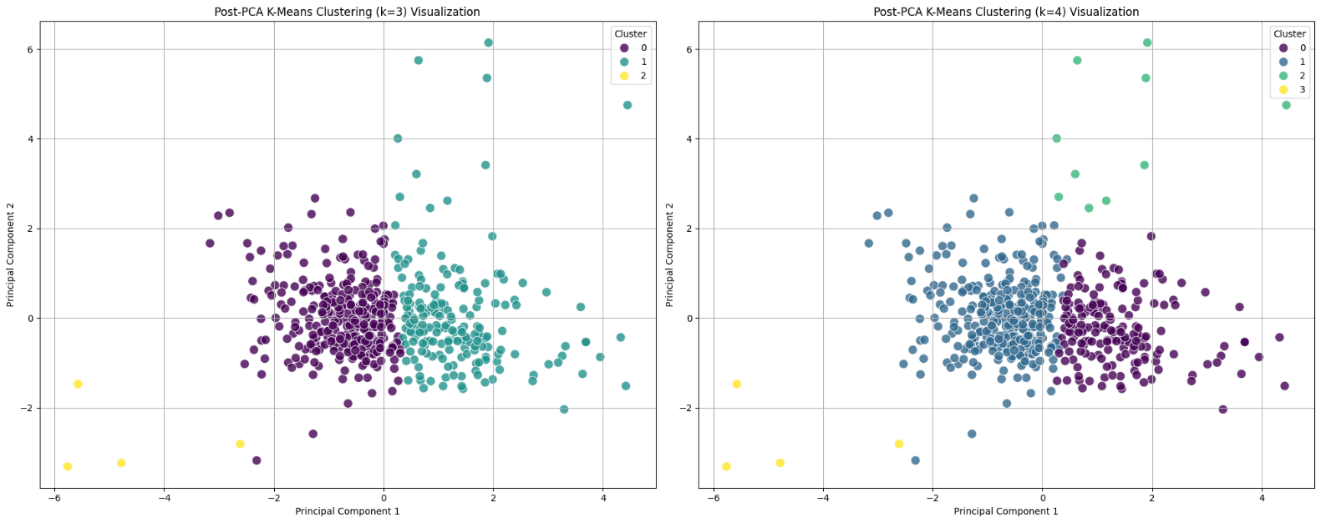
When we compare Pre-PCA and Post-PCA clustering, the main change is how PCA reshapes the data. Pre-PCA K-Means, K=4, produced several moderately sized clusters, with outliers somewhat visible but still grouped with other companies. The Post-PCA K=4 solution clearly separates the extreme outliers: the 4-company High Growth Niche and the 10-company High Cap cluster stand out, while the rest of the companies are absorbed into larger, more cohesive clusters.
Looking more closely at Post-PCA K-Means, the differences between K=4 and K=3 are clear. With K=4, the smaller high-cap growth companies are isolated from the main group of established players, capturing subtle growth differences among large firms, but the cluster sizes are highly imbalanced. Additionally, this K treats the outliers as their own group which can make interpretation and the decisions tricky.
However, with K=3, the 10-company High Cap cluster merges into the Established Players, resulting in three more balanced and intuitive groups, Average Performers, Established Players, and High Growth Niche. I believe this setup is better for practical analysis because each group is large enough to derive meaningful insights, making the clusters easier to analyze and compare.
There is however a trade-off with K=3, it loses the subtle distinction between high-cap growth outliers and the main large-cap group that K=4 preserves, but the gain in clarity and actionable segmentation does make K=3 the more useful choice overall.
As we can see, PCA essentially emphasized the most important dimensions, making it easier to identify unique, high-variance companies.
Pre and Post Cluster Profiling by Sector
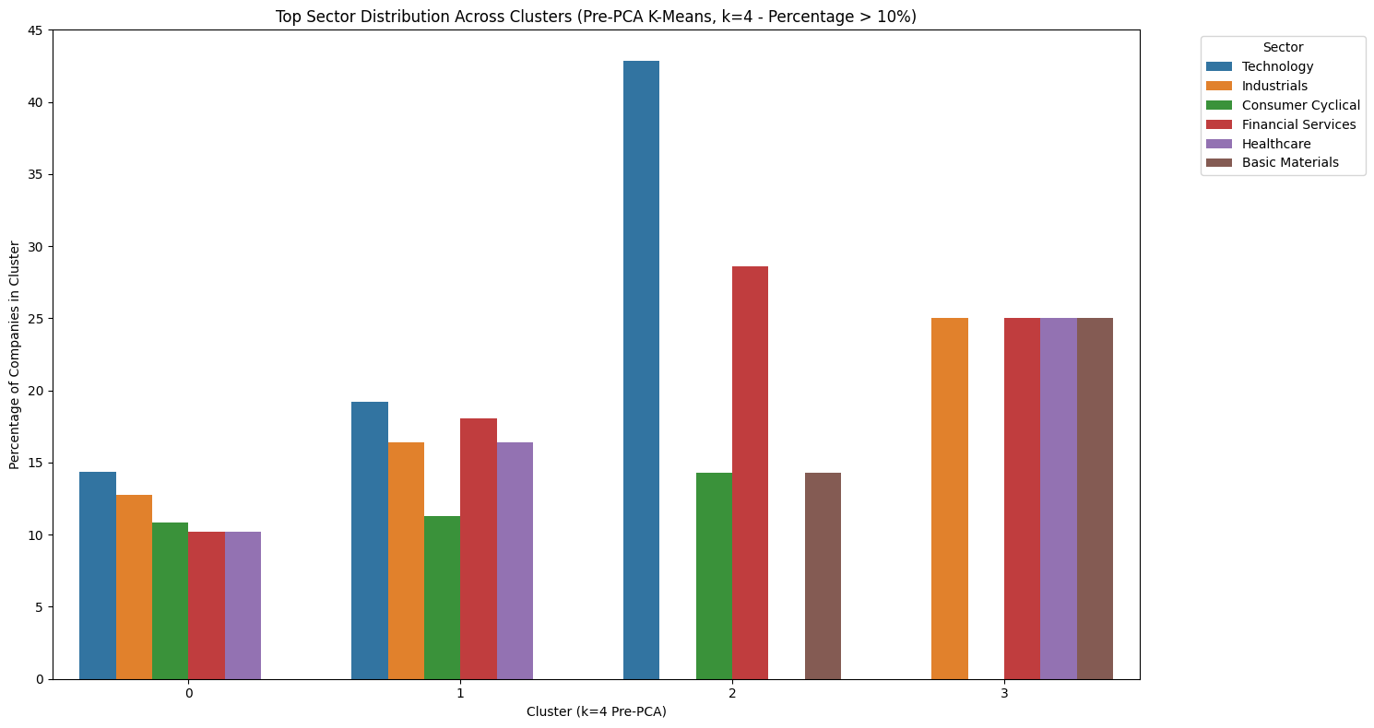
Pre PCA K Means Clustering K=4 Sector Profile

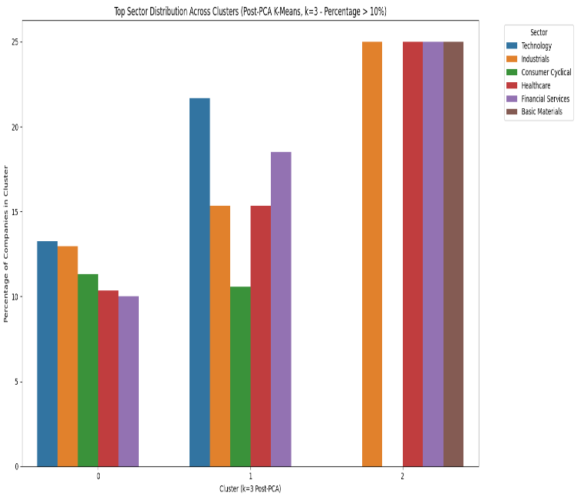
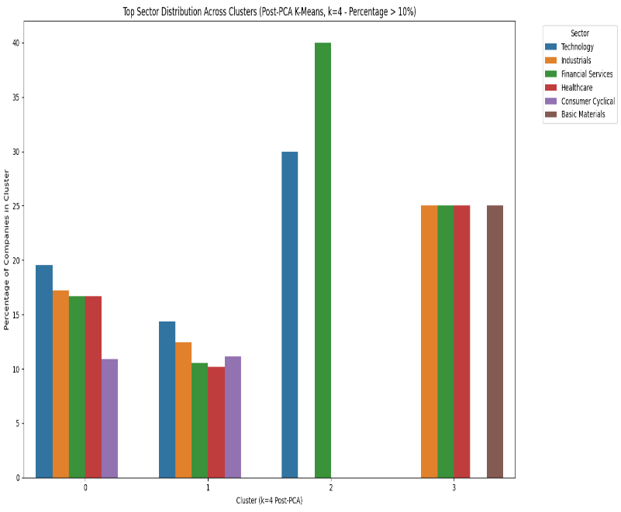
Post PCA K Means Clustering K=4 Sector Profile Post PCA K Means Clustering K=3 Sector Profile
Looking at the Sector Analysis, Pre and Post PCA, one thing stands out: there exists an established core which includes Basic Materials, Financial Services, Healthcare, and Industrials sectors that always cluster together forming a tight, consistent group. When we translate this to the real financial world, the grouping of these sectors makes sense. These sectors include mature, stable companies that tend to have predictable cash flows and similar business models, so the clustering naturally pulls them together.
Important changes that PCA bring to the picture is with the growth-oriented sectors, especially Technology and Finance. In the Pre-PCA graph, we see that the clusters were based more on raw features, which made it harder to pick out the standout companies.
However, Post-PCA K=4, isolates a High-Cap Growth Outlier cluster of 10 companies, mostly in Tech and Finance, which are really driving extraordinary growth. When we reduce to K=3, it merges this group into the Established Leaders, simplifying the clusters and making the structure more balanced and easier to interpret, but it also hides some of those subtle distinctions among the top performers. Both Post PCA K clusters do still retain the High growth Niche as distinct clusters
Pre and Post Cluster Profiling by Industry
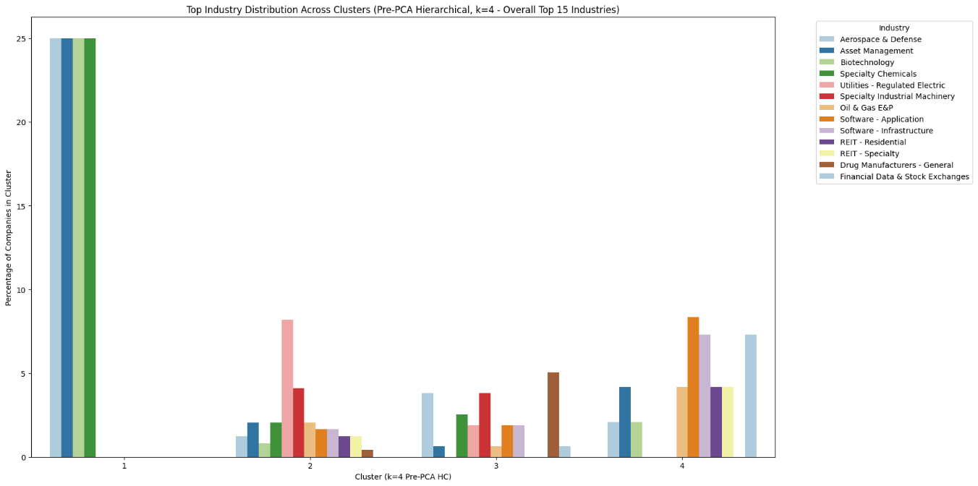
Pre PCA K Means Clustering K=4 Industry Profile
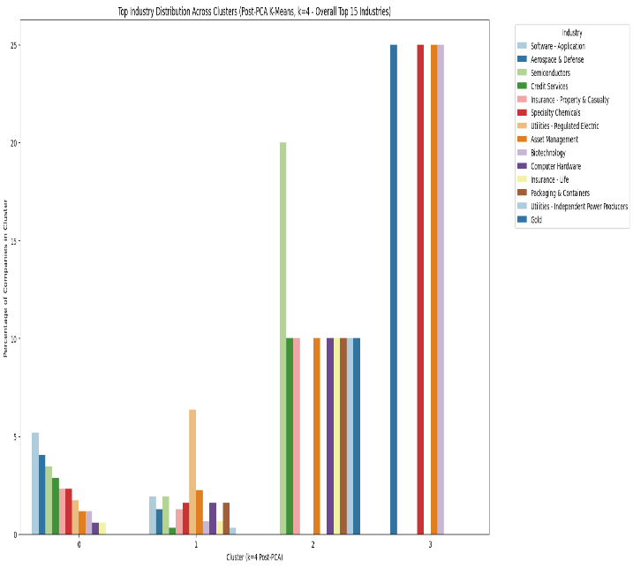
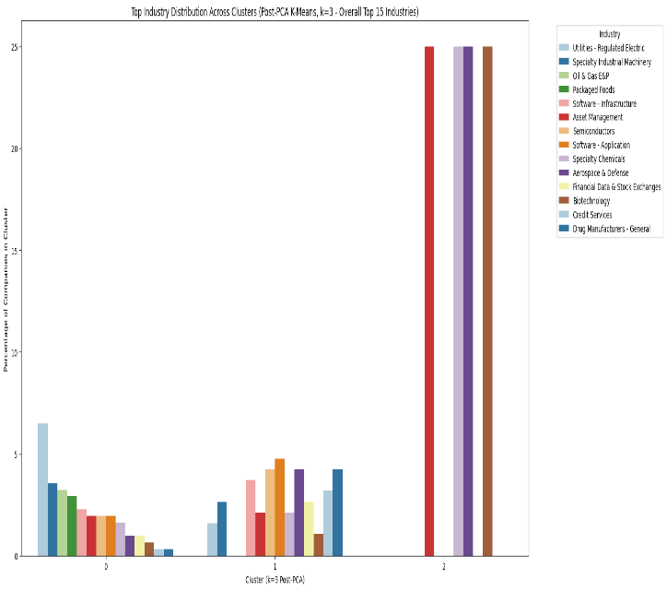
Post PCA K Means Clustering K=3 Industry Profile Post PCA K Means Clustering K=4 Industry Profile
Comparing the Industry Profiling pre and post PCA, we see another 4-Industry Core similar to the Sector Profile Analysis emerge. The core includes Aerospace & Defense, Asset Management, Biotechnology, and Specialty Chemicals, they remain intact pre and post PCA, demonstrating a very unique segment of the market. This aligns with what we see in the real world because these companies often have share specialized operations, IP, and regulatory constraints. As a result, their clustering is unaffected by PCA or changes in K, showing that some structural features are non-negotiable.

Looking closer at PCA, it does dramatically sharpen the focus on growth and high-value niches. Pre-PCA K=4 identifies a High-Risk Niche dominated by Semiconductors, Computer Hardware, and Gold/Insurance, whereas Post-PCA K=4 isolates a High-Cap Growth Outlier cluster defined by Semiconductors and Credit Services that is driven by high PC2 (Growth/Productivity).
Other industries like Utilities remain stable across transformations, showing consistent low-growth, low-volatility characteristics. When we again reduce Post-PCA K=3, we see the growth niche get absorbed into a single Established Leaders cluster, increasing internal diversity but simplifying interpretation.
Here too, while K=4 provides that finer granularity for industry insights, K=3 still delivers a more balanced and actionable view, separating 3 distinct groups.

Agglomerative Hierarchical Clustering
Agglomerative Hierarchical Clustering is another type of unsupervised learning, but it works differently from K-Means. Instead of starting with randomly chosen cluster centers, this method starts at the opposite end. Every company begins as its own individual cluster, and then the algorithm slowly merges the closest clusters step-by-step. Over time, these tiny clusters join together to form bigger groups until everything becomes one large cluster.
This whole process is visualized through a dendrogram, which is a tree diagram that shows exactly when and how different groups were merged. The height of each merger tells us how similar or different those companies (or clusters) were. Lower merges mean higher similarity, and taller merges show groups that were more different and didn’t combine until later.
Once a cut height is decided, we get the final grouping of companies or number of K which then follows the analysis of clusters.
Further, I chose Ward’s method because, unlike methods like average linkage that just look at the distance between clusters, Ward works by minimizing the variance within each cluster. As a result, we expect to get more compact and cohesive groups, which is exactly what I wanted for capturing meaningful patterns in company size, growth, and profitability.
This learning technique was also repeated twice, pre and post PCA.
Pre PCA
The dataset still used pre PCA carries all original features, which meant lots of correlations, and noisy relationships across Market Cap, Revenue Growth, Employees, EBITDA, and so on. The dendrogram reflects this complexity clearly.
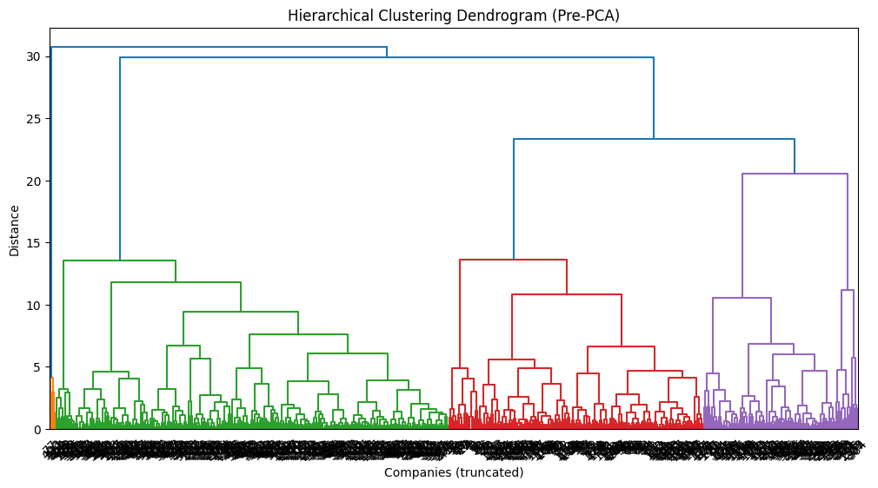
- The lower part of the dendrogram contains many short merges, which shows that some companies were extremely similar across the raw features.
- Higher up, we see very tall mergers, meaning a lot of clusters only came together at the last moment.
- Based on this dendrogram, the cut height chosen was around 12-13, resulting in K =4 clusters.
The resulting Clusters are as follows:
Hierarchical Clustering Pre PCA Centroids
 | Log_Marketcap | Signed_Log_Ebitda |  | Log_Currentprice | Log_Fulltimeemployees | Revenuegrowth
1 | -0.499 |  | -10.707 | -0.406 | -0.063 | -1.446
2 | -0.649 |  | -0.031 | -0.537 | -0.320 | -0.304
3 | 0.956 |  | 0.332 | 0.290 | 0.917 | -0.006
4 | 0.096 |  | -0.022 | 0.906 | -0.693 | 0.843

- Cluster 1 :4 members Outlier/ Unique Extremes
  - Tiny, highly unprofitable companies with shrinking revenues that sit far from the market core
- Cluster 2 :244 members General SPF 500
  - These are the below-average but stable performers. The firms here are smaller than the market median, with near-average profitability and modest growth. They form the backbone of the average market
- Cluster 3 :158 members Mid-Tier
  - This contains the established leaders. They are the largest, most profitable companies. They dominate in size and earnings but show little growth.
- Cluster 4 :96 members Specialized Group
  - This cluster highlights the high-growth innovators that are moderately sized companies but who are also achieving rapid revenue growth and high valuations with efficient operations. They stand out as the dynamic, fast-growing part of the market.
Post PCA
After applying PCA, the entire dataset was transformed into new components that captured the main patterns of variance (like company size, growth efficiency, and profitability). These PCA components also removed correlations in the data, which made the clustering process more stable and less sensitive to extreme values.
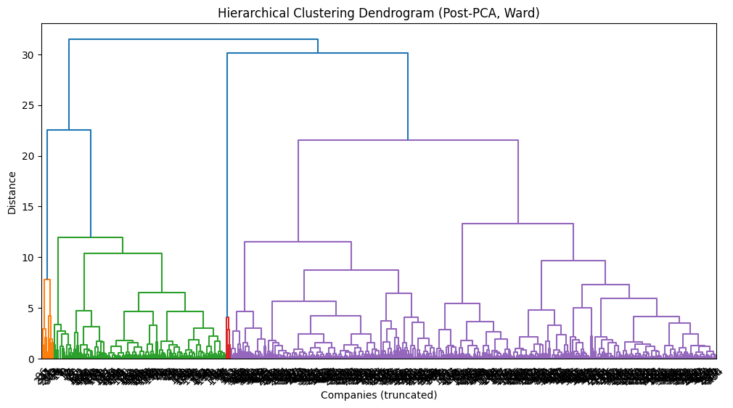
- This dendrogram visualized after the PCA looks slightly better. We can see that the mergers are more evenly spaced. As well as the overall shape feels comparatively more organized and less chaotic.
- Since the biggest jump occurs at around 30, the cut height is somewhere around 30, leaving K=2.
- Based on that, here are the new Post PCA clusters
Hierarchical Clustering Post PCA Centroids
 | PC1 | PC2 | PC3 | PC4
1 | 1.572 | 0.166 | -0.358 | -0.053
2 | -0.590 | -0.062 | 0.134 | 0.020

- Cluster 1 : 137 members
  - These are the large, high-value firms that have slightly above-average growth but lower profitability relative to price. Mostly Technology and specialized Financial companies.
- Cluster 2 : 498 members
  - This represents the market core. It has smaller, more diverse companies with near-average growth, profitability, and stability. Captures the broad market core and average performers.
Pre Vs Post PCA Agglomerative Hierarchical Clustering
Clustering Method | Cluster Label | Number of Members (Size) | Within-Cluster Sum of Squares (WCSS)
Post-PCA | Cluster 1 | 137 | 550.18
K=2 | Cluster 2 | 365 | 1213.79
Pre-PCA | Cluster 1 | 4 | 13.59
K=4 | Cluster 2 | 244 | 451.72
 | Cluster 3 | 158 | 331.23
 | Cluster 4 | 96 | 490.05

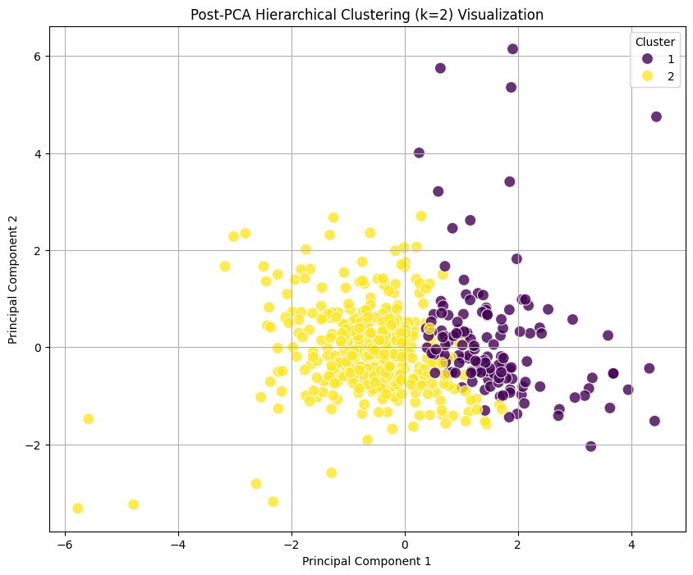
When we compare the Pre-PCA and Post-PCA K-Means results, the difference is pretty clear. In the pre-PCA version that has four clusters, the model finds tighter, more detailed groups in spite of the noise. The total WCSS is also comparatively lower than Post PCA, which means the clusters are more cohesive and the structure of the data is captured better. It basically separates the companies in a way that makes sense and keeps similar ones together.
However, after PCA, when we move to two clusters, everything gets simplified (which in a way is to be expected because PCA is all about dimensional reduction). The model essentially compresses the entire market into just two big groups, and as result of that, the WCSS goes up a lot. The clusters as we can see from the scatter plot look looser and more blended, and the balance between them is uneven.
There are still benefits to the post PCA model. It cuts down the noise and makes the main financial patterns stand out, especially things like company size and growth. The final result here is definitely easier to interpret, and it gives a very clean, high-level view of the market, specially if the goal is to explain the main split in the data or communicate a simple story.
But the tradeoff is that we lose nuance, i.e the smaller distinctions that the four-cluster version was able to catch (which in a way could have just been noise). The differences between different types of large companies, or the separation between fast-growing firms and more stable ones, get washed out. The more detailed structure that existed in the four cluster solution is now gone.
So, in this case while the pre-PCA gives a richer and more detailed picture, the Post-PCA offers a simpler but less precise one. As a result, I think the better choice really depends on whether the goal is depth or simplicity.
Pre and Post Cluster Profiling by Sector
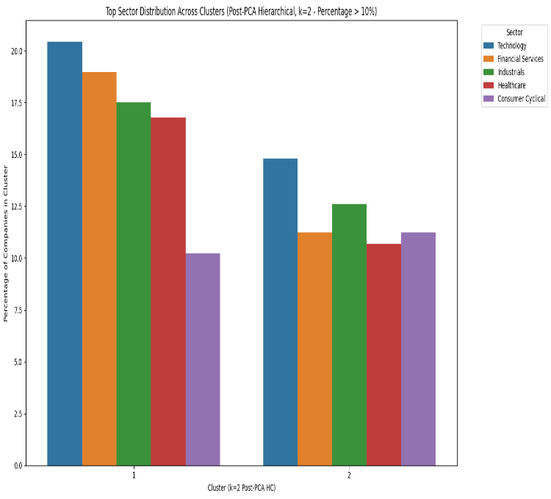
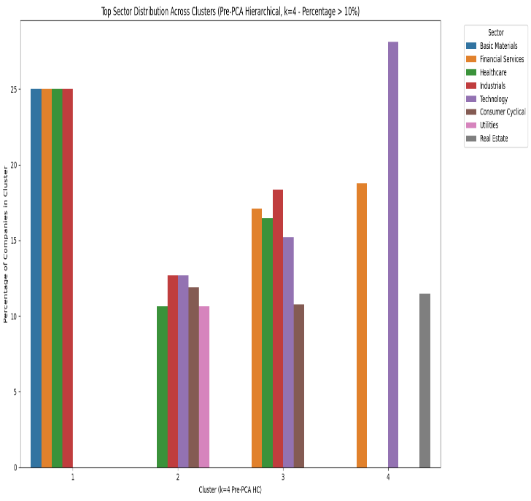
Pre PCA Hierarchical Clustering K=4 Sector Profile Post PCA Hierarchical Clustering K=2 Sector Profile
In the Pre-PCA K=4 model, the market splits into four clear groups, each with its own sector personality. The clusters have real differences in how they’re built, one is tech-heavy, another leans toward traditional core sectors like Industrials and Healthcare, another has a stronger Utilities presence while the last one represents the tiny outlier group with its evenly mixed sector profile. All of these distinctions make sense because the raw financial features capture a lot of nuance.
After applying PCA, however the picture changes completely. Instead of four distinct groups, we end up with just two big clusters. The sector identities that were so clear before PCA mostly disappear. The more specialized clusters like the Utilities-heavy group or the tech-growth cluster are now blended into a much larger, more general cluster. PCA’s goal here was to keep only the strongest financial signals, and in this dataset, that basically meant Size and Growth..
Because of this, the outlier group from the Pre-PCA model, that aligned with Pre and Post PCA K means, doesn’t survive in the Post-PCA Agglomerative Hierarchical Clustering version. Those four companies get absorbed into one of the main clusters.
In the Post-PCA K=2 model, the first cluster ends up with a more concentrated mix led by Technology and Financial Services, while the second cluster is a broad, diversified catch-all kind of category. It reflects the simplified structure PCA has now created.
Pre and Post Cluster Profiling by Industry
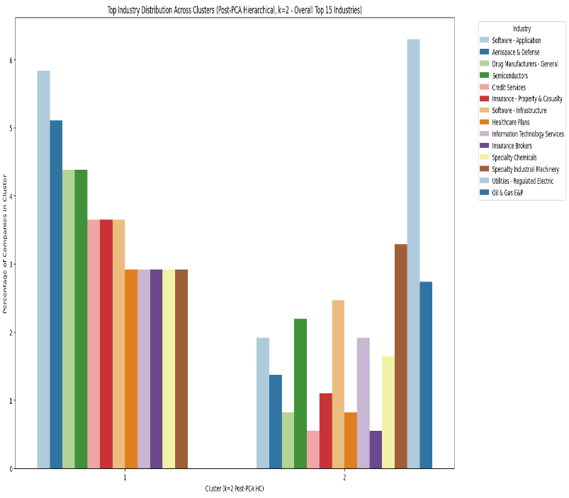
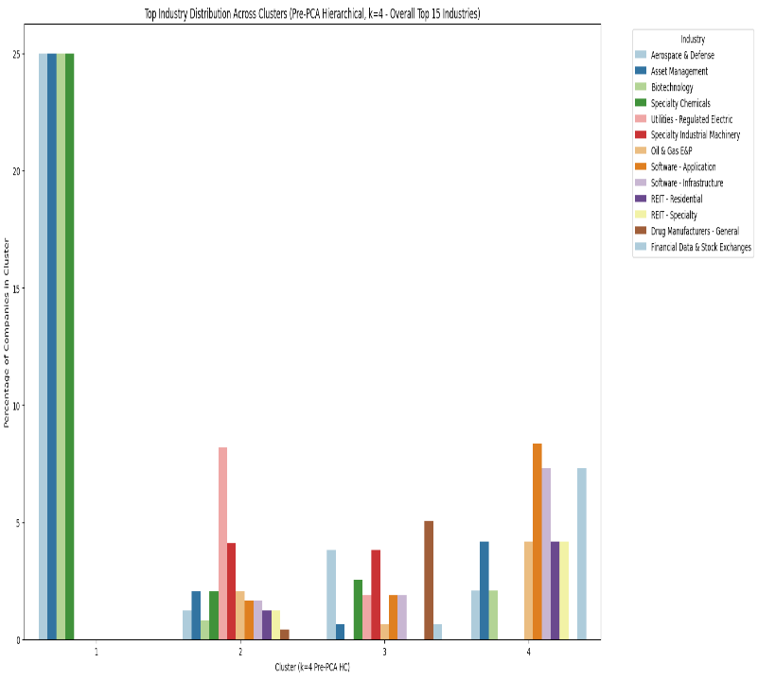
Pre PCA Hierarchical Clustering K=4 Sector Profile Post PCA Hierarchical Clustering K=2 Sector Profile
Looking at the Industry Profiles pre and post PCA, the tiny four-company outlier group , Aerospace & Defense, Asset Management, Biotechnology, and Specialty Chemicals, that survive pre and post PCA in the K means technique, is only present in the Pre-PCA Agglomerative Hierarchical K=4 model. After PCA, these companies like we also saw in the sector profile, got absorbed into the larger clusters.
Before PCA, the market split into four very meaningful clusters. One cluster is clearly high-growth, dominated by Software and Financial Data companies. Another focuses on R&D-heavy industries like Drug Manufacturers and Semiconductors. A third is more defensive, anchored by Utilities and Industrial Machinery. And finally, the tiny outlier group captured those unique, extreme cases. Each cluster highlighted a different economic driver, and the industry profiles made it easy to see how companies separate based on things like innovation, growth potential, and stability.
However, after PCA, the picture changes dramatically. The model collapses everything into just two clusters causing the previous detailed profiles to disappear; high-growth software companies, capital-heavy utilities, semiconductors, industrials, they all get blended. One cluster becomes a broad growth aggregation, mixing Software with Aerospace and Healthcare, while the other is a generalized market catch-all led by Utilities but diluted by many smaller industries.
While again, the PCA does make the structure cleaner and highlights the dominant financial dimensions, like Size and Growth, the trade-off is clear as day. We lose the finer, industry-level distinctions that were visible in the pre-PCA clusters. The result is easier to interpret at a high level but not as useful for understanding the specific financial behaviors of different industries.

Discussion
Looking back at everything I ran in this project — from testing K-Means and Hierarchical Clustering, to comparing their pre-PCA and post-PCA results, a pretty consistent picture of the S&P 500 has started to emerge. Even though each unsupervised learning model sliced the data a little differently, the same underlying drivers kept showing up across all approaches: company size, growth behavior, and overall financial stability. These factors were found to have shaped the clusters more strongly than anything else.
Clustering Quality and Model Behavior
One of the main patterns that became evident was just how sensitive the pre-PCA models were to noise. Before dimensionality reduction, the clusters were loosely formed, especially when the algorithms tried to separate companies that were only slightly different. This was most obvious in the pre-PCA Hierarchical results and in the pre-PCA K-Means solutions with higher K values. We get one or two compact groups, and then at least one messy, stretched-out cluster that clearly didn’t have strong internal structure. This lines up with what the general knowledge of clustering tells us; If we cluster financial or any data straight from the raw features, the clusters can end up being highly unstable or just noise. However, once we extract the main structures with the help of PCA, the groups become way clearer and more reliable.
The application of PCA immediately changed that dynamics seen pre PCA. After PCA, the clusters can be perceived as being much cleaner, more distinct, and easier to interpret, at the very least visually. PCA amplified the financial dimensions that matter most while reducing noise from less relevant features. This matches what many quantitative studies recommend: PCA can significantly improve cluster stability and interpretability, especially for markets (Zhang 2025).
Applying PCA in this dataset had a noticeable trade-off. The Post-PCA Hierarchical Clustering boiled the market down to just two clusters: one for the large, high-value firms and another for the broader, smaller-market core. It makes the overall structure easier to see, but also wiped out a lot of the finer distinctions we could still pick up in the Pre-PCA clusters, like the detailed industry and sector differences. This is a known limitation of aggressive dimensionality reduction: it simplifies the picture, sometimes a bit too much (Jolliffe and Cadima, 2016).
Interpreting the Clusters
Despite the differences between the two unsupervised learning methods, the clusters themselves were surprisingly consistent in meaning:
- There was always a distinct outlier group in the K Means Pre and Post PCA + Pre PCA Agglomerative Hierarchical Clustering
  - In the K-Means Pre-PCA and Agglomerative Hierarchical Pre-PCA clustering, we clearly saw a small outlier group that stood apart across every method. However, in the Post-PCA Hierarchical Clustering, PCA absorbed these outliers into the larger clusters, so they no longer appear separately. As such, the clustering quality of Post PCA Hierarchical Clustering was not good enough, specially when compared to the K Means technique.
- There was always a large “market core” group. This cluster included the majority of companies and represented the stable center or even the average of the S&P 500. It stayed relatively compact in all the pre-PCA models and expanded slightly after PCA due to the merging of noisier companies.
Among all the models, I think the Post-PCA K-Means K=3 solution struck the best balance. It was able to preserve meaningful segmentation/ clusters without overcomplicating the structure and avoiding the instability that shows up when K is pushed too high. It also didn’t lose too much nuance like the Post PCA Hierarchical Clustering. It aligns well with many of the cluster-quality principles of strong separation, internal coherence, and a manageable number of groups.

Conclusion
When I compare all the methods side by side, the story is pretty consistent. Pre-PCA clustering captures more granularity, the nitty gritty but can also easily be thrown off by noise. Post-PCA clustering provides a clearer, more digestible view of the market but has the risk of occasionally smoothening over subtle distinctions.
The K=3 post-PCA K-Means model offered the cleanest, most interpretable representation of the S&P 500 without losing the important differences between firm types.
The ultimate goal of this project wasn’t just to find the best model but also to understand how different techniques highlight different layers of structure in the data. Across all models, certain themes kept reappearing: the divide between massive, mature firms and fast-growing companies, the presence of a predictable market core, and the persistence of a small number of extreme outliers which even in the EDA kept skewing the visualizations.
Overall, there is consistency across clusters by different methods which gave me confidence in the patterns I found, and of course the PCA-based clustering helped bring those patterns into a clearer focus. This turned what started out as a noisy, high-dimensional dataset into a map of how companies in the S&P 500 naturally group together.
Recommendations
- Formal internal validation metrics
While WCSS and visual checks were helpful, adding other validation metrics like Silhouette Score, Davies–Bouldin Index, or Calinski–Harabasz Index would give a more objective measure of cluster quality and help confirm which K is the best choice (GeeksforGeeks 2023).
- Leverage Text Data from Long Business Summaries
Use NLP to turn business summaries into useful features for clustering. Extract key themes with TF-IDF or topic modeling. These features, possibly reduced with PCA, can add richer information to reveal patterns that financial metrics alone might miss.

Citations
GeeksforGeeks. (2023, October 10). Clustering metrics in machine learning. GeeksforGeeks. https://www.geeksforgeeks.org/machine-learning/clustering-metrics/
Jolliffe, Ian T., and Jorge Cadima. “Principal Component Analysis: A Review and Recent Developments.” Philosophical Transactions of the Royal Society A, vol. 374, no. 2065, 12 Apr. 2016, doi:10.1098/rsta.2015.0202. https://royalsocietypublishing.org/doi/10.1098/rsta.2015.0202
“Stock Classification Using PCA and K-Means for Value Investing.” Atlantis Press, https://www.atlantis-press.com/article/126015281.pdf
Larxel. (2024). S&P 500 stocks (daily updated) [Data set]. Kaggle. https://www.kaggle.com/datasets/andrewmvd/sp-500-stocks

